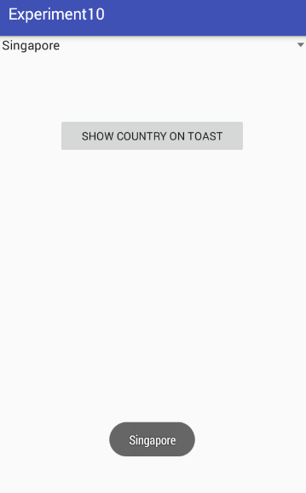 **package** commmm.gps.gauravpratapsingh.experiment10;  
  
**import** android.support.v7.app.AppCompatActivity;  
**import** android.os.Bundle;  
**import** android.view.View;  
**import** android.widget.AdapterView;  
**import** android.widget.Button;  
**import** android.widget.Spinner;  
**import** android.widget.Toast;  
  
**public class** MainActivity **extends** AppCompatActivity {  
**private** Spinner **sp**;  
**private** Button **bt**;  
 @Override  
 **protected void** onCreate(Bundle savedInstanceState) {  
 **super**.onCreate(savedInstanceState);  
 setContentView(R.layout.***activity_main***);  
 **sp**=(Spinner)findViewById(R.id.***spinner1***);  
 **bt**=(Button)findViewById(R.id.***btn1***);  
 **bt**.setOnClickListener(**new** View.OnClickListener() {  
 @Override  
 **public void** onClick(View v) {  
 String se = **sp**.getSelectedItem().toString();  
  
  
 Toast.*makeText*(getApplicationContext(),se,Toast.***LENGTH_SHORT***).show();  
 }  
 });  
 }  
}

Style.xml

<**resources**>  
  
 *<!-- Base application theme. -->* <**style name="AppTheme" parent="Theme.AppCompat.Light.DarkActionBar"**>  
 *<!-- Customize your theme here. -->* <**item name="colorPrimary"**>@color/colorPrimary</**item**>  
 <**item name="colorPrimaryDark"**>@color/colorPrimaryDark</**item**>  
 <**item name="colorAccent"**>@color/colorAccent</**item**>  
 </**style**>  
 <**string name="country_prompt"**>Choose a country</**string**>  
 <**string-array name="country_arrays"**>  
 <**item**>Malaysia</**item**>  
 <**item**>United States</**item**>  
 <**item**>Indonesia</**item**>  
 <**item**>France</**item**>  
 <**item**>Italy</**item**>  
 <**item**>Singapore</**item**>  
 <**item**>New Zealand</**item**>  
 <**item**>India</**item**>  
 </**string-array**>  
  
</**resources**>

mainActivity.java

*<?***xml version="1.0" encoding="utf-8"***?>*<**LinearLayout xmlns:android="http://schemas.android.com/apk/res/android"  
 xmlns:app="http://schemas.android.com/apk/res-auto"  
 xmlns:tools="http://schemas.android.com/tools"  
 android:layout_width="match_parent"  
 android:layout_height="match_parent"  
 android:orientation="vertical"  
 tools:context=".MainActivity"**>  
  
 <**Spinner  
 android:id="@+id/spinner1"  
 android:layout_width="match_parent"  
 android:layout_height="wrap_content"  
 android:entries="@array/country_arrays"  
 android:prompt="@string/country_prompt"** />  
 <**Button  
 android:id="@+id/btn1"  
 android:layout_width="match_parent"  
 android:layout_height="wrap_content"  
 android:text="show country on toast"  
 android:layout_margin="80dp"**/>  
  
</**LinearLayout**>